Emergency Action Plan



600 SHILOH ROAD, PLANO TX 75074

Key Notes
Emergency Response Procedures
In the event of a Life-Threatening Emergency or a building emergency:
- Call 9-1-1
- Give Location Clearly
600 Shiloh Road, Plano, TX 75074
- Listen to directions of 9-1-1 operator(s)
- Ensure the Inogen Safety line is notified: 972-992-7927

- Call the Inogen Safety Line immediately of any emergency situation
- No team member is allowed to re-enter the building during an emergency evacuation until authorized by Safety Officer, emergency personnel, etc.
- All team members are to muster and remain at their designated assembly area until further instruction is given.
- Management will notify the ranking fire or emergency personnel of any potential trapped person(s) and a general area of their location.
- When there is an outside entity working or visiting, their escort is responsible for accounting for them during in the event of an emergency or evacuation.
- Smoking is NEVER permitted during any type of emergency event.

Policy
Inogen has developed plans to address emergency situations that may arise at the facilities and which may threaten human health and safety, and damage company assets. Management is responsible for implementing the Emergency Action Plans. These Emergency Action Plans will meet the following objectives:
- Provide a means of notifying employees, customers and local authorities of an emergency situation.
- Provide a safe and orderly method of evacuation of employees, visitors, and
contractors from Inogen premises.
- Account for all employees, visitors, or contractors who occupy Inogen premises at the time of evacuation, should one occur.
- Provide emergency first aid treatment or summon emergency medical assistance for injured individuals.
- Provide training and needed information to those employees responsible for taking action in the event of an emergency.
- Signs as required by ordinance, regulation, or law will identify emergency exits. Employees are required to be familiar with the location(s) of alarm pull stations and emergency exits.
- Training on Emergency Action Plan will take place during new employee orientation, when changes occur in the action plans, and periodically as coordinated by the Safety Department

Purpose
To establish the policy and procedures regarding management’s and employee’s response to various emergency situations. Examples of an emergency are fire, tornado, earthquake, and bomb threat.
Overview:
The procedures cover the following topics:

Emergency Response

Emergency Response Team

Fire Response and Reporting

Emergency Evacuation

Headcount Procedures

Muster Points

Active Assailant/Active Shooter

Tornado Shelter

Bomb Threat

EMERGENCY RESPONSE
If an employee/individual is injured, the initial response is to call 9-1-1 and relay all pertinent information to operator and request emergency medical response or professional medical care. Following the call to emergency services, notify the Safety Officer, Safety Committee Personnel, or First Responder.
Preferred Clinic
Concentra, All Locations
Customer Care Directory: (866)-944-6046
Hours: 8:00am-8:00pm
Nearest Hospital
Methodist Richardson Medical Center
2831 E. President George Bush Hwy, Richardson, TX 75082|
Phone(469)204-8000

Injured Individual
- All injured individuals must report their injury to their immediate supervisor.
- Any contractors/visitors that are hurt on-site must report their injury to their assigned escort.
Senior Management/First Responders
- Treat the injured using supplies from first aid cabinets as needed.
- In the event an employee is seriously injured and requires professional medical care.
- If the individual is not mobile or has a life-threatening injury or illness. Arrange for emergency care and transportation. When in doubt call 9-1-1.

EMERGENCY RESPONSE TEAM(ERT)
Emergency Response Team Members can be identified with a red badge holder. They are responsible for:
- Ensuring immediate safety and scene control
  - Quickly assess the situation, secure the area, eliminate hazards if possible, and prevent further injuries or damage.
- Provide initial Emergency Support
  - Deliver basic first aid, CPR, or other approved methods of care within their scope of training until professional responders arrive.
- Coordinate communication and response
  - Report incident promptly, activate emergency procedures, communicate with management, and guide emergency personnel to the location of emergency.
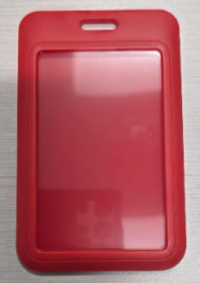

FIRE RESPONSE AND REPORTING
If a fire alarm or alert is sounded or a fire is reported by an employee, regardless of the reason for the alarm or the severity of the fire, the following actions must be taken immediately:

Individuals trained and confident in the use of fire extinguishers, may attempt to suppress a small fire, until relieved by the Fire Department, the scene becomes unsafe, or until it becomes apparent that the fire cannot be controlled by fire extinguishers.
Note: Employees should never attempt to control a fire, which endangers their health. You must immediately evacuate the area when it becomes apparent that the fire cannot be controlled or when conditions become more hazardous.
Senior Management of each department
- Immediately notify the Fire Department/Police Department/Emergency Medical by dialing 9-1-1.
- Provides address of Inogen –
600 Shiloh Road, Plano, TX 75074
- Assigns an employee to wait at the facility entrance for the Fire Department to arrive and then to direct them to the location of the fire.
- Safety Manager or Maintenance Manager/Supervisor will be assigned to verify
    - That the Fire Riser Cutoff Valve that supplies water to the sprinklers of the affected area will be locked in the open position.
- All escorts must ensure they account for their visitors or contractors on site at time of emergency.
- After exiting the building, take a headcount of employees to insure all were safely evacuated. Double check that all individuals are out of the facility.

EMERGENCY EVACUATION
This procedure includes, but no limited to, internal fire, gas leak, smoke detection etc. When evacuation is required in the building, it is important to evacuate everyone out of the building in a safe and efficient manner. Team members and visitors are encouraged to familiarize themselves with 2 exits closest to their immediate work area assignment and 1 other exits not in their “usual” work setting.
No team member is authorized to go to their lockers to retrieve any items during a shelter in place.

The following procedures should be followed in the event of an evacuation.
Employees/Contractors/Visitors
- Safely stop all work in your area.
- Proceed to the nearest exit. Do not push or shove anyone while exiting building.
- Proceed to the designated Emergency Assembly Area and account for the employees that were working in your area.
  - After exiting building make your way to the main parking lot for accountability at your assigned muster area.
Senior Management
- Notify local emergency agency (Fire department, police department, hazardous materials team, etc.) The following message must be relayed to all team members.
  - First team member outside will call 9-1-1 and relay all pertinent information to emergency response dispatch.
- Checks all areas of their respective departments, restrooms, and public areas to verify that employees and individuals are evacuated.
  - This should be a quick sweep of the work area. If not safe to do so, do not continue.
- The receptionist is responsible for keeping the Guest Register and for removing that register in case of an emergency.

HEAD COUNT PROCEDURES
This part of the procedure is in place to account for all personnel working in the facility at the time of an evacuation. The steps below should be followed based on location, work status, or area of operation.
All team members must:
- Evacuate immediately utilizing the nearest emergency exit doors or route.
- Make their way to their assigned muster point in the front parking lot.
- Counters-Verify that all team members are accounted for (Managers/Supervisors at the muster points will have eyes on their team members)
- Verifiers-Relay over radio when all team members are accounted for

Muster point | Area of Operation | Department
1 | Sales
2 | Manufacturing | Compressors/POC’s
3 | Manufacturing | Office Staff/R&D
4 | IT
4 | Human Resources/  Enterprise Enablement
5 | Manufacturing | Repairs/RMA
6 | Customer Care | TCC
7 | Manufacturing | Warehouse/Columns
8 | Manufacturing | Ship/Pack

Note: When one or more team members are unaccounted for no individuals are authorized to re-enter the building to conduct a search. Inform the ranking officer from the fire/police department of any missing individuals and their last known whereabouts.

MUSTER POINTS

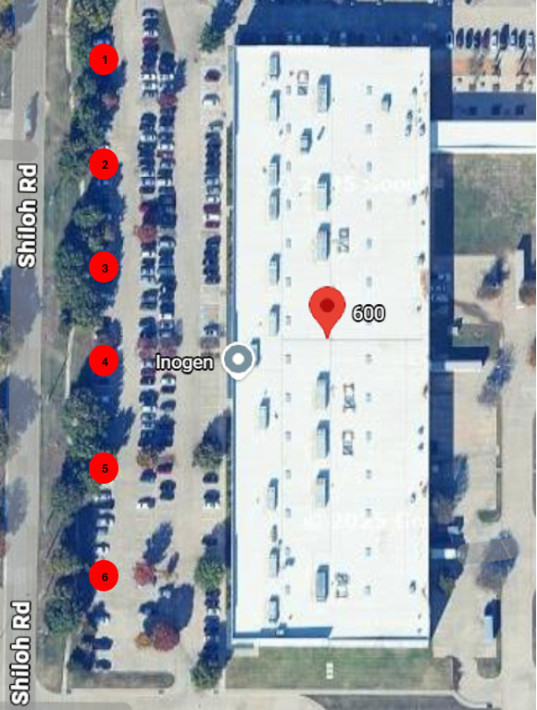
8
7

ACTIVE ASSAILANT/SHOOTER
An active assailant is an individual who is engaged in causing physical harm or attempting to kill, people in a confined and populated area. Active assailant incidents are often unpredictable and evolve quickly. Amid the chaos, anyone can play an integral role in mitigating the impacts of an active assailant incident.
In the event of an active assailant:
DO NOT GATHER IN THE ASSEMBLY AREAS.
RUN: Evacuate If Possible
- If there is considerable distance between you and the gunfire/armed person, quickly move away from the sound of the gunfire/armed person. If the gunfire/armed person is in your building and it is safe to do so, run out of the building and move far away until you are in a secure place to hide.
- DO NOT ATTEMPT TO RETRIEVE BELONGINGS FROM LOCKERS, DESKS, ETC.
- Keep your hands visible to law enforcement.
- Take others with you, but do not stay behind because others will not go.
- Call 911 when it is safe to do so. Do not assume that someone else has reported the incident. The information that you are able to provide law enforcement may be critical, e.g. number of shooters, physical description and identification, number and type(s) of weapons, and location of the shooter.
HIDE: Hide silently in as safe a place as possible
- If the shooter is in close proximity and you cannot evacuate safely, hide in an area out of the armed person’s view.
- Choose a hiding place with thicker walls and fewer windows, if possible.
- Lock doors and barricade with furniture, if possible.
- Turn off lights
- Silence phones and turn off other electronics.
- Close windows, shades and blinds, and avoid being seen from outside the room, if possible.
- If you are outdoors and cannot RUN safely, find a place to hide that will provide protection from gunfire such as a brick wall, large trees or buildings.
- Remain in place until you receive an “all clear” signal from Blackboard Connect.

FIGHT: AS A LAST RESORT
- If you cannot evacuate or hide safely and only when your life is in imminent danger, take action. Look for Items that can be used as a weapon. (Fire extinguisher, chair, etc.)
- Attempt to incapacitate or disrupt the actions of the assailant. If you are alone,
- Act with physical aggression toward the assailant.
- Throw items at the assailant if possible.
- Call 911 when it is safe to do so.
Immediately after an incident:
- Wait for Local Law Enforcement officers to assist you out of the building, if inside.
- When law enforcement arrives employees must display empty hands with open palms and obey all commands given to them.
Key Notes
- Understand that gunfire may sound artificial. Assume that any popping sound is gunfire.
- If there are two or more persons in the same place when a violent incident begins, you should spread out in the room to avoid offering the aggressor an easy target.
- Be mindful that violent attacks can involve any type of weapon, not just a gun. Knives, blunt objects, physical force or explosives can be just as deadly as a gun. The suggested actions provided here are applicable in any violent encounter.
- Plan ahead: Visualize possible escape routes, including physically accessible routes for students and staff with disabilities and others with limited mobility

TORNADO/SHELTER IN PLACE
Prior to any tornado emergency, Management will designate safe shelter area within the building for employees and individuals. There are some general guidelines that may be used to aid in the selection of such spaces. Inogen safe shelter areas are the employee restrooms located on the 1st floor. First aid kits, medical supplies, and flashlights are available in easily-accessible locations when required.

The following procedures should be followed in the event of an evacuation.
All Team Members/Contractors/Visitors
- Safely stop all work in your area.
- Gather your personal belongings, in your immediate area, if safe to do so - necessities only, in the event you cannot return to the area such as keys, wallet/purse, cellphones and medications, and remember only if it is safe to do so.
  - No team member is authorized to go to their lockers to retrieve any items during a shelter in place.
- Proceed to the nearest Shelter in place location.
- Proceed to the designated Emergency Assembly Area and account for the employees that were working in your area.
  - No team member is to leave the shelter in place location(s) until clear by proper personnel (Safety Manager, Plant Manager, etc.)
Senior Management
Tornado Watch Procedures
- A Tornado Watch means that conditions are right for severe thunderstorms and possible tornadoes to develop. When notified of a tornado watch in the area, Senior Management will tune the radio to the National Weather Service channel to stay current on the storm progress.
Tornado Warning Procedures
- A Tornado Warning means a tornado has been seen or detected by radar. Senior Management will inform all employees and individuals to take cover in shelter areas immediately.

BOMB THREAT
When someone calls and says there is a bomb in the building, the following steps shall be performed:
Employee receiving threat
- Keeps the caller on the line as long as possible. Asks them to repeat the message. Tries to write down every word spoken by the caller.
- Asks the caller where the bomb is located and when it will go off.
- Tells the caller that the building is occupied and detonation of a bomo could result in the death and injury to innocent people.
- Pays particular attention to background noises, such as music playing, kids in the background, engine noises, etc.
- Listens to the voice to identify gender, voice quality, accent, speech impediments.
- If the caller hangs up, DO NOT HANG UP THE PHONE! Sometimes, phones can be traced back to the source.
- Immediately notify management and describe the threat.
Senior Management:
- Calls the local authorities to report the incident. Follows all recommendations and guidelines provided
- If no instructions are given, search the premises for any suspicious devices or packaging.

